
Slice X
Fractional Property-
blockchain technology

Table of Contents
Introduction 3
Goals 4
Problem Statement 4
Challenges in the real estate industry 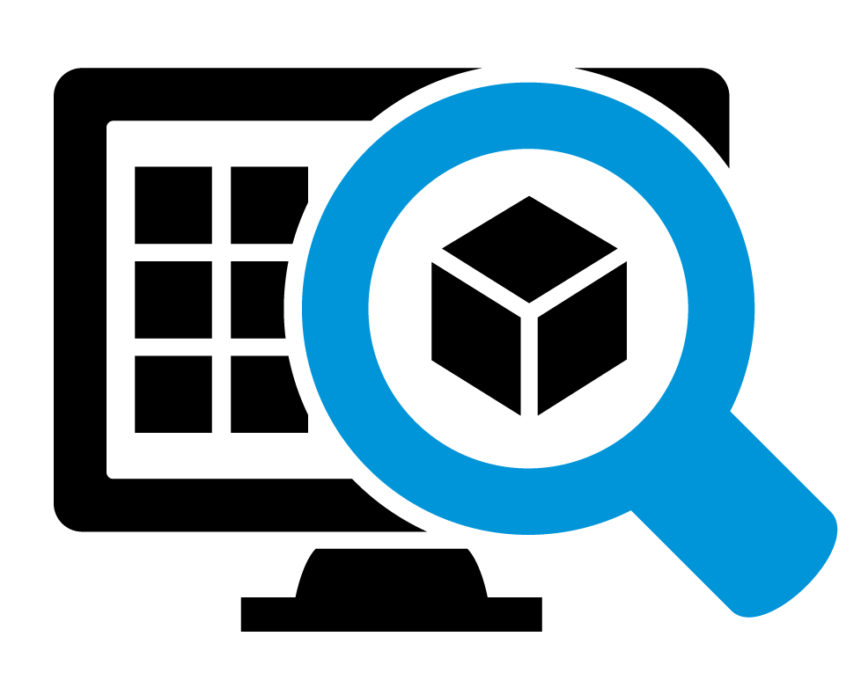 5
Solution 6
Fractional property in Blockchain 7
Fractional ownership in Slice X 8
Tokenization in Slice X 9
Benefits of Tokenization 11
Tokenomics 13
Supply plan 13
Rewards 15
Company 15
Foundation 17
Slice X infrastructure 18
Slice X demographics 20
Working of Slice X 23
Pillars of Slice X 27
Comparison of Slice X and Traditional Approach 29
Legal Aspects 31
Conclusion 32

Introduction
Real estate investment is one of the most powerful ways of earning passive income. The ameliorated mediums of technology have provided us with a different platform for investment in real estate. Fractional property also commonly known as tokenization is one such blockchain technology where real estate investments take place.

Slice X is a fractional property platform enabled with blockchain. It provides users with a platform where they can save their money to purchase a property to assist them in releasing equity through their existing property. Slice X makes use of the BNB chain. The BNB ecosystem is implemented by Slice X for tokenization. This application is beneficial for real estate developers as it offers tokenized solutions for investment and transactions. It provides a decentralized property registry along with real-time transactions.

Goals
Our goal is to facilitate real estate investors by providing fractional ownership which makes use of the BNB chain enabled by blockchain.

Figure 1 Goals of Slice X

RoadMap of Slice X

Figure 2 Road map of Slice X
Details:

- Phase 1: Q1 2022 - Q2 2023
  - Whitepaper and Tokenomics (Completed)
  - Smart Contract Development (Completed)
  - Website Development (Completed)
  - Founding Team Assembled (Completed)
  - Onboard Advisors (Ongoing)
- Phase 2: Q3 2023 - Q4 2023
  - Presale Preparation (Q3 2023)
  - Marketing Strategy
  - Investor Outreach
  - Legal Compliance
  - Presale Launch (Q4 2023)
  - Token Sale
  - Early Investor Engagement
  - Platform Testing
- Phase 3: Q1 2024 - Q2 2024
  - Token Distribution (Q1 2024)
  - Distribute Tokens to Investors
  - Lock-up Period (if applicable)
  - Platform Development (Q1 2024 - Q2 2024)
  - Enhance User Interface
  - Implement Additional Features
  - Community Building (Ongoing)
  - Grow and Engage with the Community
- Phase 4: Q2 2024 - Q3 2024
  - Property Acquisition (Q2 2024)
  - Identify and Acquire Real Estate Assets
  - Tokenization (Q2 2024)
  - Tokenize Acquired Properties
  - Launch Tokenized Properties
  - Marketplace Expansion (Q3 2024)
  - Expand Offerings to New Regions
- Phase 5: Q4 2024 and Beyond
  - Portfolio Growth (Ongoing)
  - Continuously Add New Properties
  - Secondary Market Launch (Q4 2024)
  - Enable Token Trading
  - Explore Strategic Partnerships (Ongoing)
  - Ongoing Development and Improvement (Ongoing)

Problem Statement
The real estate business holds one of the strongest values in the field of business. This diverse industry helps in gaining a tremendous profit ratio for businessmen. The real estate business faces issues due to slow paper processes. It consumes a lot of time and effort due to a lack of technology advancements. The major delay in the real estate business is also it difficult for people to invest and attain benefits from this domain.

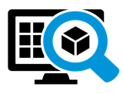
Challenges in the real estate industry

Limited inventory in the market
Limited inventory makes the real estate business extremely challenging. This is because the investors cannot have an accurate prediction about the profit and investment rate. The value of profit growth is unpredictable. Builders who have invested a great amount in the business might certainly face a lot of challenges due to rapidly changing investment rates.



Uncertain income
The profit rates and interest are uncertain. Builders or newbies who have invested a high amount in a certain property might face a huge loss if their invested business does not reach a certain level. Due to this the income rate is unpredicted.


High rates
Investing in large assets will cost a lot. A person who will solely own a property will have to save a huge amount before investment. Moreover, if a person prefers to shift his investment, he might have to risk a large amount. The transaction amount at one time is also huge, in case of a small mishap the client might face a huge amount of loss.



Time-consuming
The paperwork and government regulations are time-consuming. It requires a lot of effort which makes it difficult for the investors to easily process their investment.



Difficulty for beginners
People who are new to this domain might not have proper guidance and a road map. They would either be asked to invest a huge amount or might invest in such a property that does not give high-profit rates. Entry-level individuals might also not be able to see a future in this domain, due to lack of guidance.

Solution
Slice X focuses on solving all the major issues in the real estate industry. It aims to improve the user experience in the field of real estate and also emphasizes the future growth and development of this industry. Slice X is a modern approach to real estate investment. Based upon the concept of fractional property enabled with blockchain technology, it aims to provide the best facilities to its customers. Slice X is a platform where the user can invest in a property and also save the amount to purchase a certain property. Depending upon the budget of the client, they can purchase and have a certain level of account. Moreover, users who do not have a large amount can invest and attain profit while investing as low as 100$. Since there are multiple owners of a certain asset to thus a loss is also equally distributed among all the owners. Thus, making a certain individual less burdened. The following are the main targets of this application:
- Distributed ownership
- Gain profit by investing a small amount
- Save money for buying a new asset
- Invest in different types of assets
- Operate the application either as an investor or a business owner
- Safe and secure platform
- No extra government charges
- The keys of customers are private
- No third-party access and involvement
- Customers can track their profit
- Liquidity as property can be easily shared and bought
- Reduced friction as no high agent commission or fees are involved
- All tokenized real estate assets

Fractional property in Blockchain
Blockchain technology has become immensely secure due to its tremendous benefits and improved and secure efficiencies. Similarly, Slice X is based on the same concept. It is a shared equity platform where multiple investors can share partial assets of a property. Blockchain security makes Slice X a secure platform. Since there is no centralized database, so thus, it restricts access from hackers. It also restricts unnecessary third-party fees. The amount is settled through smart contracts, so it does not charge any extra fares.
Individual investors are brought together to share a property through Slice X. It provides a safe, secure, and reliable platform for investors to invest their assets. Unlike that traditional approach, here property is handled by an entity i.e., is a trusted platform. Through Slice X different investors can put forward their property for purchase to attain profit. Investors having a small amount for investment can also attain an advantage through this platform.

Fractional ownership in Slice X
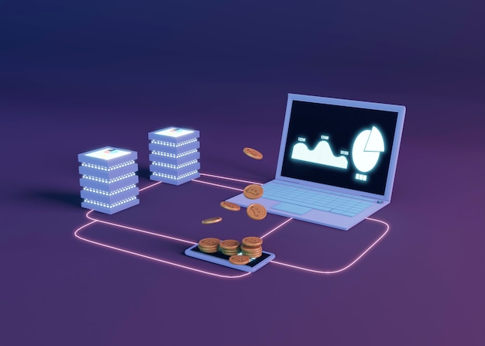

The fractional ownership in Slice X opens the door for all categories of investors, to attain benefits. It provides a platform for low-budget investors and also for investors who to purchase bigger assets. Slice X distributes a certain property to multiple investors so that all the investors can attain individual benefits and the owner can acquire profit so that owners can gather benefits. It provides a platform to small-ticket investors so that they can also gain capital goals before acquiring bigger profits. Fractional ownership is a legal equity which allows multiple investors to own a single property, however, investors need to select a secure platform to gain benefit. Slice X which is enabled with blockchain provides a secure platform so that individual investors can freely and securely invest their property into the right asset to gain benefits.

Tokenization in Slice X
Slice X is a platform where a user can divide and equally invest in an asset. It helps them safely and securely invest in their cryptocurrencies. As a result, the investors can attain benefits as per profit and can also save their valuables for the future. The users who invest in the assets are recognized as token holders or owners of the portion of the asset. The token holders constantly get a revenue stream from the tokens of the block. The asset is divided to different users into equal parts, with all of them having the same rights on the property.



Slice X does not demand its users to have a large amount for investment. With Slice X you can invest in any digitized property and tokenized with only 100 Euros. Users can invest in any assets and gain their capital goals. It helps in democratizing investment in illiquid markets. Its goal is to facilitate its users to have huge success rates by investing in any assets that could be beyond their age while investing physically. The users invest in the required assets with Binance. This is because BNB is one of the leading cryptocurrency exchanges. It is one of the strongest altcoin trading. Based on which tokenization in Slice X makes it a useful platform for investment.

Benefits of Tokenization

Real estate tokenization is explained as fractionalizing the property into tokens from the decentralized database. The tokens can represent different artefacts of real estate investment. It provides ownership of part of the property and also the ownership of the entire property. It might also represent a right to share in the property or might represent the interest rate on the property. It has provided tremendous benefits to real estate investment, following are the few prominent benefits.



Creates liquidity
The use of blockchain technology makes the real estate investments secure. This makes the transaction processes easy and reliable. Based on this the investors can easily diversify their portfolios. It minimizes the risks and thus the users can easily create liquidity.



Easy entry for beginners
Tokenization helps in improving small-scale investment. This makes it easy for entry-level investors to easily invest in their desired area of investment. Unlike the traditional approach, it does not require higher capital.



Lower transactional cost
The use of blockchain technology makes the transactional cost low. Tokenization provides real-time capitalization and improved accessibility. Based on this the cost received to different parties is received fast and at low cost.

Tokenomics

Supply plan
Slice X has a fixed supply of 1bilion tokens. Out of the total token supply, 20% is for token sales and 30% is for rewards. The team consumes 5% of the total tokens whereas the company in total gathers 12% of the total tokens. Each allocation is tiered around for nearly 6 months, until the funding close date.
Token Distribution
Serial no. | Allocation | Percentage
 | TOTAL SUPPLY | 100%
1 | Token Sale | 20%
2 | Foundation | 3%
3 | Advisory | 5%
4 | Company | 12%
5 | Team | 5.00%
6 | Rewards | 30%
7 | Liquidity Pool | 10%
8 | Marketing | 10%
9 | Airdrop | 5%
Table 1 Token distribution
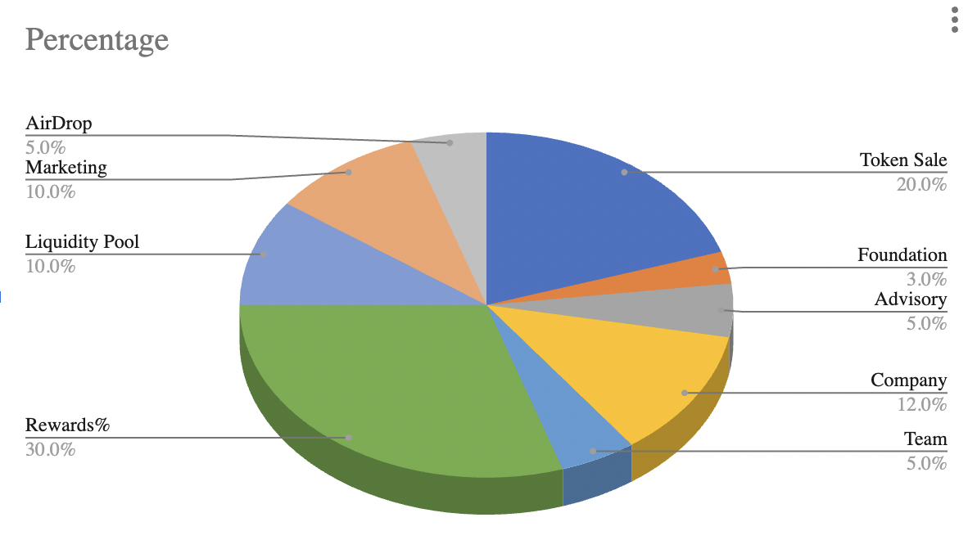
Table 2 Pie graph of token distribution

The tokens are allocated in a total of three rounds. The tokens, price and the amount raised in different in each of these rounds. Furthermore, the price also differs in each of these three rounds. The details of all these three rounds are elaborated in the table and the graph below.
Serial no. | Allocation | TOKENS | Percentage | PRICE | RAISED AMOUNT
 | TOTAL | 200,000,000 | 100.00% |  | 1,000,000.00
1 | First Round | 50,000,000 | 25.00% | 0.0035 | $175,000.00
2 | Second Round | 50,000,000 | 25.00% | 0.0045 | $225,000.00
3 | Third round | 100,000,000 | 50.00% | 0.006 | $600,000.00
Table 3 Token sale
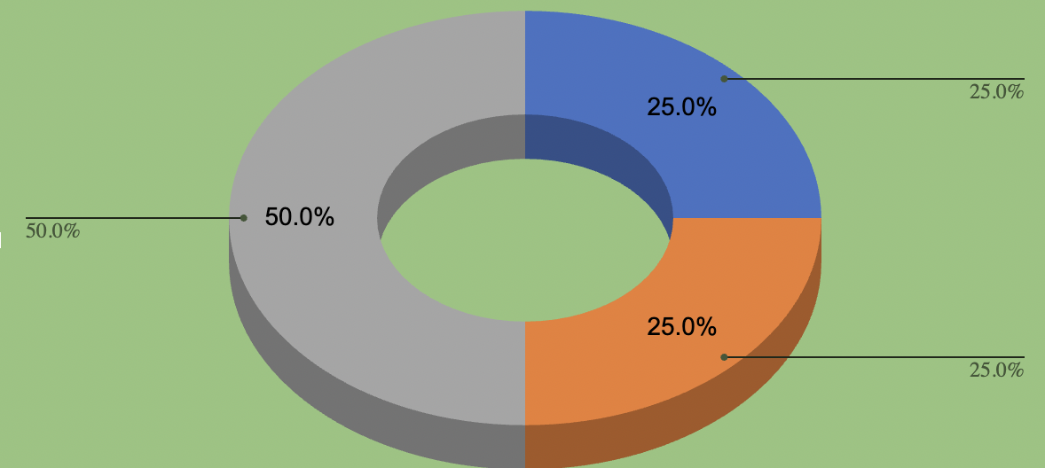
Figure 3 Pie-graph of the token rounds

Rewards
Slice X is nearly estimated to provide 30% of the total supply of rewards. The total amount in figures for reward is 300,000,000. This amount remains constant throughout the token rounds. Moreover, the rewards are not disturbed so the loyalty of the customers remains constant. The reward criteria are also set to acquire the attention of new users. Furthermore, when a user completes an investment, a reward is provided to them. This also results in grabbing their attention. Slice X is also planning to develop a learning platform. This platform is to facilitate users who are new in the fractional property domain. The users are encouraged to participate in growing their learning skills.

Company
The Slice X company attains nearly 12% of the total supply. This amount remains fixed throughout the process. The tokens allocated in the company are distributed and maintained for 6 months.

 |  | Quantity | Percentage | Explanation | Vesting Months
 | TOTAL SUPPLY | 1,000,000,000 | 100%
1 | Token Sale | 200,000,000 | 20% | 2 months of Cliff, 20% TGE per month | 5
2 | Foundation | 30,000,000 | 3% | 6 months of Cliff, 3.75% TGE per month | 24
3 | Legal/ Advisory | 50,000,000 | 5% | 1 month of Cliff, 3.96% TGE per month | 24
4 | Development & Operations | 100,000,000 | 10% | 1 month of Cliff, 5.28% TGE per month | 18
5 | Team | 50,000,000 | 5.00% | 1 month of Cliff, 5.28% TGE per month | 18
6 | Rewards | 300,000,000 | 30% | 6 months of Cliff, 2.78% TGE per month | 36
7 | Liquidity Pool | 50,000,000 | 5% | 3 months of Cliff, 100% TGE per month | 1
8 | Marketing | 100,000,000 | 10% | 1 month of Cliff, 5.28% TGE per month | 18
9 | Reserves | 120,000,000.00 | 12% | 18 months of Cliff, 8.33% TGE per month | 12
Table 4 Token Allocation
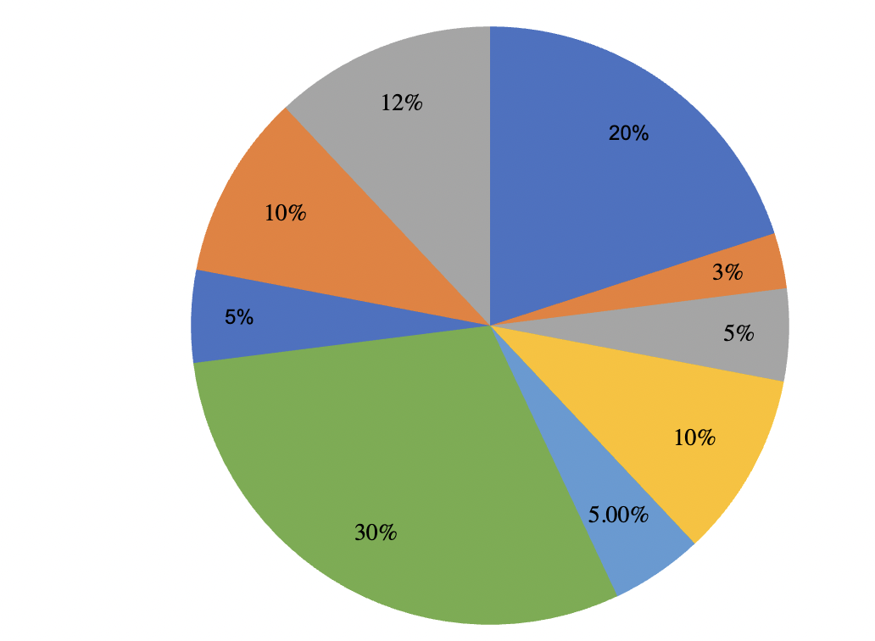
Figure 4 Pie graph of the token allocation table

Foundation
Slice X focuses on making property investment easy and reliable. It also targets fixing the gap between digital and physical property investment. The foundation team aims to develop a separate team and employees who will target to fulfil the process of making property investment easy. The total foundation of Slice X remains fixed throughout the completion of crowd base funding close date. 3% of the total supply is dedicated to the foundation section.

Slice X infrastructure

The current version of Slice X is applicable on IOS, Android, Windows and other operating system software. For financing it makes use of BNB, whereas it is based upon the concept of fractional property. The server, website and blockchain technology are integrated to make it a productive fractional ownership platform for its investors. It provides APIs for third-party integration. The standardized API libraries permit additional parties to interact, thus making it a proactive blockchain-based software.

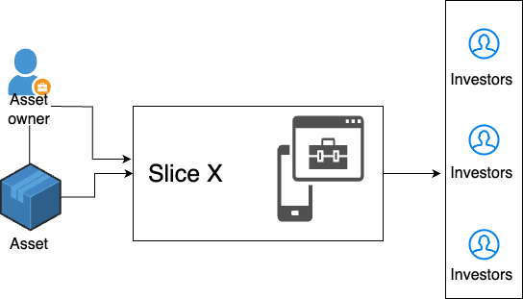
Figure 5 Slice X connection with Assets and investors
The Slice X platform allows asset owners to present their assets for equal illiquidity. An individual can invest in the property and can attain profit depending upon their investment.
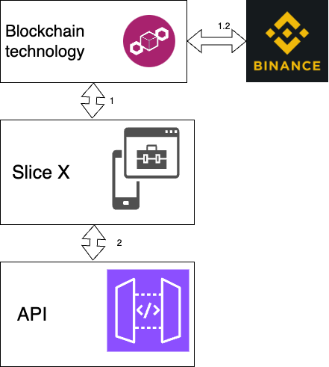
Figure 6 Slice X components integration
Description:
- Blockchain technology is integrated with Slice X which is based on the concept of fractional property. The blockchain technology makes the platform a safe and secure medium for investment.
1.1. The blockchain technology makes use of Binance currency for investment. It is one of the most widely used cryptocurrencies. Through it, the financial amount can be converted into different other types of currencies.
- Slice X is integrated with API gateways for third-party integration.

Slice X demographics

To explain the demographics of Slice X mainly the users and assets will be considered. Different users who can attain an advantage from Slice X will be elaborated on. Different assets which can actively be part of the demographics will be listed.
Table 5 Represents the users in Slice X
Users | Individuals:  Investors who have a small amount for investment can attain benefit from Slice X. They can either be the owner of an asset who gains the rental profit or the investors who acquire the capital goal profit.
Enterprises:
Larger corporations who are targeting to attain better annual revenue can acquire benefits from Slice X. Moreover, enterprises who want the freedom to divest can acquire benefits from this platform.
Funds:
These directly point to the owners of larger assets who are seeking to present a portfolio of their assets. Through Slice X they can put forward their competitive yield and strategies of the assets.

Table 6 Represents the assets in Slice X
Assets | Residential:  The most common type of assets in Slice X is residential properties. This is because users can easily present their assets to attain residential benefits. The individual investors can also acquire their profit through the residential assets.
Condos:
These assets are relatively expensive as compared to different other assets presented. The presales offered by real estate developers provide bank-oriented loans, thus making it a long-term beneficial investment.
Commercial:
Slice X also includes commercial areas for investment. This is because through this the users can invest in their targeted commercial area, and acquire benefits from the calculated area.

NFT
The Slice X tokens are non-fungible which are non-interchangeable unit of data. These can be sold and traded. The Slice X registry stores information in a digital system on the blockchain. The NFT flow has a wallet to the admin and user. The rent and the fractional unity is sent to the user along with the treasury, however only the mint is directly forwarded to the treasury.

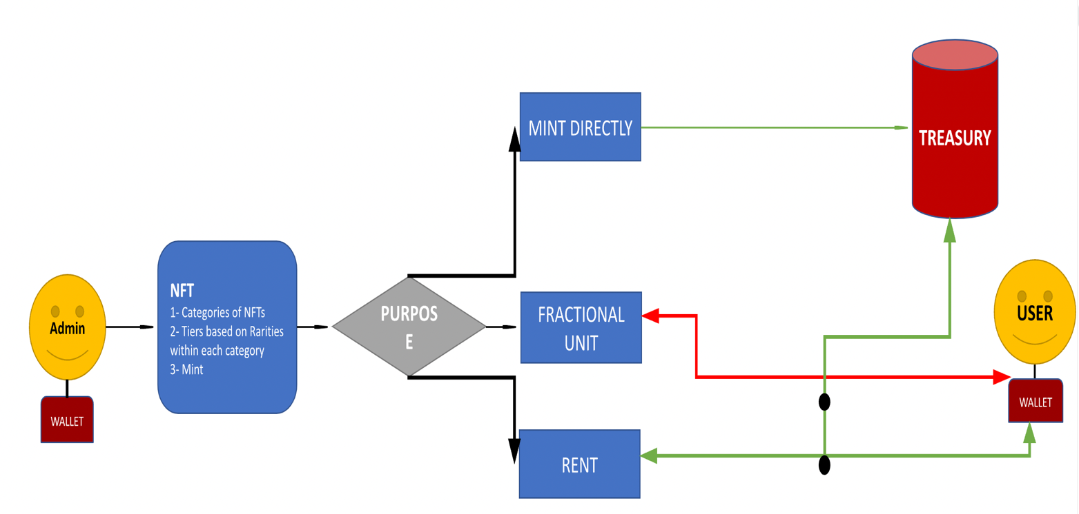
Figure 7 Flow chart of NFT

Stacking Model
The Staking model in Slice X is used to make predictions using different other models. All different levels of models serve as a meta data to strength the model. The token staking model in Slice X, incorporates the staking pool to stake the amount total and the send the validation fee cut to treasury.
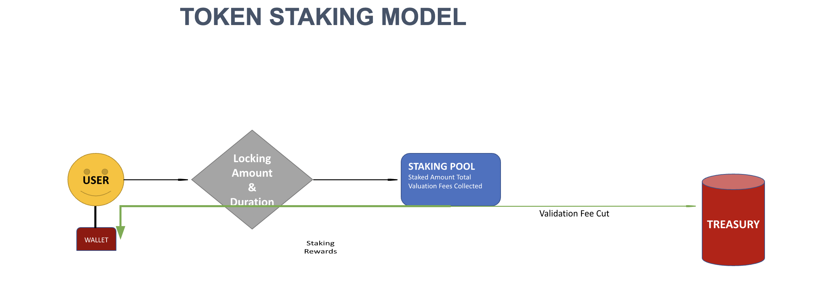
Figure 8 Flow chart of staking model

Working of Slice X
This section will illustrate in detail the workings of the Slice X platform. It explains how the infrastructure of the platform works.
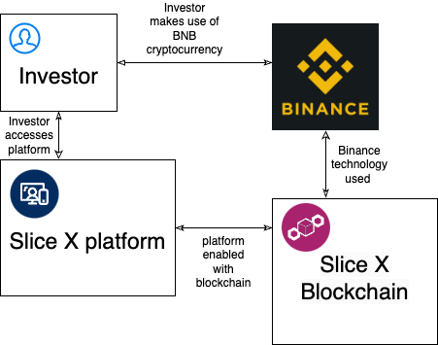
Figure 9 Working of Slice X from the investor perspective
Description:
- The investor or multiple investors investing in the same asset access the platform. They can view the available assets and also invest their desired amount. They can view the calculated profit, they might attain from the asset.
- The Slice X platform is enabled with blockchain technology. It has incorporated all the set of benefits with blockchain. All the functional operations and processes of the blockchain are incorporated.
- The blockchain technology used in Slice X is BNB. Through this all the crypto trading takes place. It makes the trading process easy, reliable and more efficient.
- The investor also makes use of the BNB process and through this, they perform all their investments.

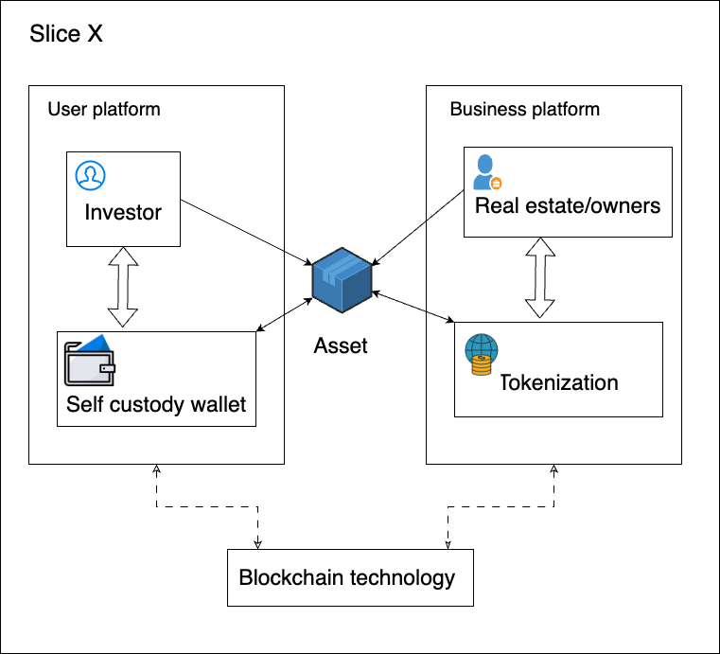
Figure 10 Internal infrastructure of Slice X
Description:
- Slice X application has two main platforms each enabled with blockchain technology
- The user platform mainly involves the operations and functions of a user
  - An investor can look for an asset with multiple ownership
  - The amount invested in cryptocurrency
  - All the required amount and earnings are stored in the self-custody wallet
  - The wallet and the keys of the wallet are not available and accessible by third parties
  - The investor can invest in an asset provided by the business owners
  - The whole functionality and process is enabled with blockchain technology
- The business platform includes all the operations and functions of the owners
  - An owner puts forward his asset to an investor for investment
  - All the assets are tokenized, which makes it safe and secure
  - The financial dealing of the assets is done in crypto

Pillars of Slice X
Slice X a fractional property-based application enabled with blockchain has few pillars. The application is completely operational based on these pillars.

  Client and business-based platform | Slice X is a platform which supports growth and assistance to both clients and business-seeking individuals. The clients can attain benefits through profit, which is the amount invested, whereas the individuals who have put forward their assets can also gather benefits from Slice X. Thus, based on this it can be demonstrated that this platform suits both parties.

  Self-custodial wallet | Slice X is a platform which provides its users with a complete self-custodial wallet. This terminology is also referred to as a decentralized wallet. It supports such a cryptocurrency wallet which provides its users complete control over their funds, keys and private keys. Slice X restricts third parties to access the funds and details of the users. Resultantly, it makes Slice X a secure platform, and this is also one of the major aspects of Slice X development.

  Blockchain technology | Slice X's prime focus was on being enabled by blockchain. It allows users to invest and perform financial operations through cryptocurrencies. This makes it safer from malicious attacks and also restricts unnecessary access to different individuals. Slice X blockchain technology is based on Binance BNB.

Comparison of Slice X and Traditional Approach
Slice X is a blockchain-enabled fractional ownership platform that differs from the traditional approach in tremendous ways. It allows better access to real-time assets where the users can invest their finances depending upon their required situation. It is based upon the concept of fractional ownership and thus makes liquidity easy. The data is protected due to the involvement of a decentralized database. It uses the BNB approach for crypto exchange. This makes it easy for the buyers to easily invest in their required assets.

The use of Binance makes Slice X a secure and different platform for real estate investors. Moreover, the users are not limited to a certain group, they can be builders, owners and also beginners. It does not charge the users with any additional maintenance or interest charges. It also protects the confidentiality of the users from third-party users, thus making it internally a secure fractional property platform.
Slice X | Traditional approach
Online trading and marketplace | Listing of buyers and sellers
No intermediaries i.e. involvement of third parties; brokers lawyers etc. | Requires an active involvement of third-party individual
Liquidity is easily created | The seller has to wait for the buyer for liquidity.
Fractional ownership helps in investing in an asset with a small amount | The seller cannot invest until he/she has attained a certain amount for investment
Decentralization makes the transaction and investment process secure and free from third-party access | The majority of the processes require lawyers and third-party involvement, thus making it not a safe platform.
Cost-effective, as user can easily start investing and no extra transactional cost is required. | Requires a lot of unnecessary costs and also charges extra fees from the buyers and sellers.

Legal Aspects
Slice X has provided different platforms to investors and owners. No third party is associated between the investor and owner. The investor has the right to invest their desired amount in the business they are interested in. Based on their invested amount and the value of the asset the profit amount is generated. The profit amount is added to the self-custody wallet of the user. The user cannot involve any different wallet. This is to ensure the safety. On the other hand, owners can set forward their property to be owned by multiple investors through tokenizing. Similar to the user the owner can also not involve any third party. The profit rate is solely decided based on the value of the asset. There is no personal fee charged by Slice X, so thus in case of loss, Slice X does not compensate the users.
The blockchain medium used is Binance, and thus the users and owners can only make use of Binance. They are not permitted to make use of different blockchain platforms, as it is not supported by the Slice X system. Slice X is solely based upon the concept of fractional ownership and the blockchain technology is Binance. All the operations happening on both business and owners' platforms are based upon the concept of fractional ownership. The self-custody wallet concept for users is dependent upon a decentralized wallet system. Depending upon which the users can have their private keys. Lastly, both investor and owners' platforms operate separately. They are also managed by separate admin authenticators, so if an investor wishes to shift to the business owner, they need to have a separate account.

Conclusion
This document provides an insight into Slice X. It provides details of his infrastructure and also draws a picture of its concept. Slice X is based upon the concept of blockchain technology, so thus includes all the benefits of blockchain. The technology used is Binance and it is built upon the concept of fractional ownership. Slice X is operatable on various platforms, including IOS, Windows Android and various other operating software. The functions and operations are based upon the business and user's platform, these functions process in each of the platforms differently. The business assets are based upon the aspect of tokenization. This makes it a secure and protected platform. The users’ keys and information are protected and cannot be accessed by any third-party individual.


Slice X allows multiple individuals to own a property. They can invest in the property and can attain benefits based on their investments. It is a platform for low-budget investors. It is a platform where users can quickly attain benefits. Slice X is based upon a decentralized database, so thus it provides strong and high-level security and protection to its users. It provides self-custody wallets to its investors to store amounts and tokenized assets for business owners to invest. The internal processes of Slice X are handled by calling various APIs. Slice X resolves the problem of limited market inventory and also the other security concerns.

